
Middlesex County Archery Association County Clout Championship and Visitors Clout Tournament. Record Status and Tassel Status.
To be held on Saturday 31st October 2026

Fee: £10. adults; £8 under 18. Closing Date 24th October (Late Entries Adult
£12.00, Junior £10.00)
Payment to be made via BACS to Middlesex Archery Ac No. 61156284 Sort Code 40-43-46

Use Ref:” CT” plus your surname
Organiser: Jonathan Simons 7 Dawlish Drive, Pinner, Middlesex, HA5 5LJ. Telephone: 07879446698. Email: clout@middlesexarchery.org.uk.

Venue: Ashford Sports Club, Short Lane, Stanwell, Staines, Middlesex TW19 7BQ

Equipment Inspection: 9:30 am Assembly: 10:15am
Sighters: 10:30 am (6 sighters in each direction)

Two-way Double clout (Imperial distances) - All participants should have previous instruction in Clout shooting.

Judges: David Strong, Terence Williams and Meera Shah and Shamsul Hussain

Distances:
Open 180yds Ladies 140yds
Juniors 140yds, 120yds, 100yds, 80yds according to age on 26th Oct.
NB late entries on the day must shoot the distances already set out, and space permitting
If you would like the Target List/results posted to you, please send 2 large S.A. E’s

Middlesex County Archery Association County Clout Championship and Visitors Clout Tournament.

To be held on Saturday 31st October 2026

Record Status and Tassel Status.

ENTRY FORM

First Name | Surname | Gender | AGB No | Bow Style | Clout Distance | Senior/ Junior | DOB  Junior | Left or Right-handed Archers | Fee
Mobile Number: |  |  |  | Email Address:
Club:
Mobile Number: |  |  |  | Email Address:
Club:
Mobile Number: |  |  |  | Email Address:
Club:
Mobile Number: |  |  |  | Email Address:
Club: |  |  |  |  |  |  |  | Total Fee:

A record of attendees’ contact details will be kept for Track and Trace purposes should anyone test positive for Covid-19 within 14 days of the tournament.

You should ask yourself the following questions before attending: Do you have a high temperature? Do you have a new, continuous cough? Do you have a loss of, or change to, your sense of smell or taste? Are you in a household or bubble with someone who has tested positive for Covid-19 in the past 14 days? Are you in a lockdown area? If you answer 'yes' to any of these, then you should not attend the competition.
Hot Drinks and snacks for sale at Ashford Sports Club from 9 am. Toilets from 9 am. Bar available later.
Awards for County and Visitor Recurve, Barebow, Compound, Asiatic and Longbow, according to entry.
Archery GB membership cards will be inspected at registration.
Per the provisions of Archery GB Protection of Children and Vulnerable Adults Policy, those who wish to take photographs at this event are required to register with the tournament Organiser.

Directions:

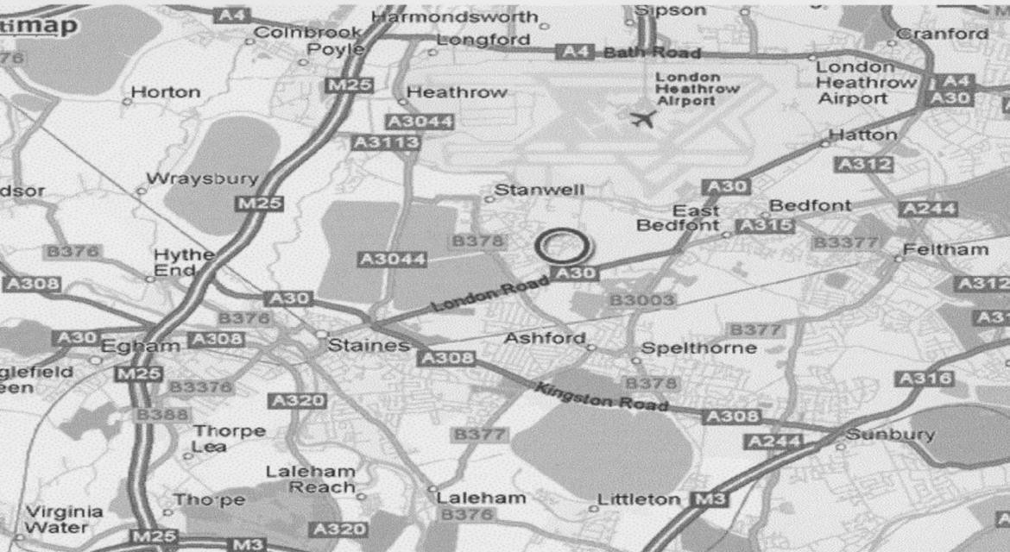
(From M25 Junction 13 (Staines junction) take the A30 towards London. Ground is third left (Short Lane) after Ashford Hospital. From London, follow the A4, then A30 towards Staines. ½ mile after Clock House Lane roundabout, turn left into slip road, follow signs to cross the carriageway, and proceed back the way you have just come for 50 yards. Turn left into Short Lane.

